

I dedicate this book to the loving memories of

Mrs Gloria Zadek.
My darling sister.

And

Mrs. Shelley Bright.
My dear cousin.

A History of
Commander Morris Moss Bright, DSC RN
in War & Peace

Second digital edition 2026

Index

Introduction 4 – 5
How it all started 6 – 8
A changing World 9 – 27
World War 2 back in the Navy 28 – 38
Morris & Burly are outstanding in WW2 37 – 39
Burly takes Bright’s to the next level 40 – 43
Remembering the past, looking to the future 44 – 55

A History of
Commander Morris Moss Bright, DSC RN
In War & Peace
By
Simon Silver

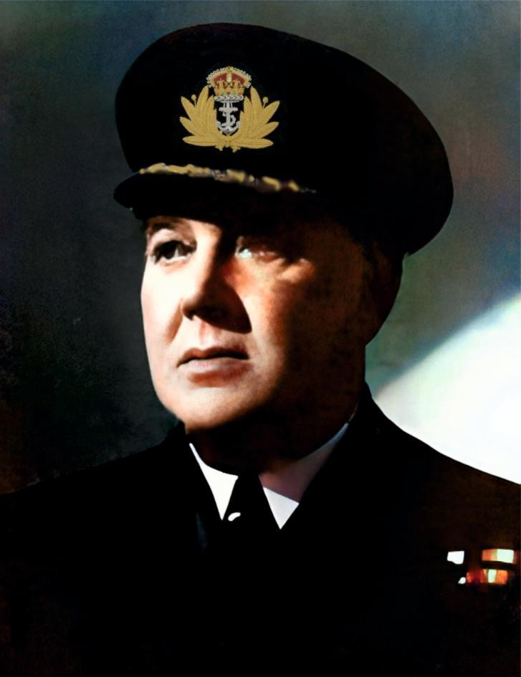

Commander Morris Moss Bright DSC Royal Navy
1890 - 1965

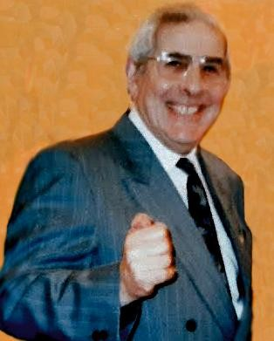
Jule Warwick Bright

1930 - 1999

Introduction.
In the 1990's my late Uncle, Jule Warwick Bright in conjunction with Geoffrey Green a famous historian who happens to be Jewish and a writer, researched and then wrote the Life and Times text of his late father Morris Moss Bright.
Morris became a Commander in the Royal Navy and was awarded the Distinguished Service Cross. My Mother, Minnie Sivia Silver (nee Bright) contributed to this story by keeping the documents and photographs, which today form the foundation of the Life site online, that I created. Many of my mother Minnie's memories and efforts to preserve the collection are contained within the text as well.
The original idea of the life text became a way of Jule to present and deliver his father's story in a structured and entertaining way. Jule gave talks on his father's naval career. He was a great personality in his own right. Jule was everything a person can be in life. Talented entertainer, do it yourself maestro and businessman. Above all he was a committed husband to Valerie and his family.
Seeing Jule delivering this story to an audience must have been a fascinating joy to witness. Few people in life have such talents. I can honestly say Jule used his to the full.
I am not by profession a writer or a historian! I have never served in the Navy or armed forces. I have been in electrical retailing for 46 years. Refrigeration and kitchen appliances are my speciality. Refrigeration has a part to play in this story as you will see. You probably are thinking why would I bother to even write this story? Especially as Jule made such a good job of creating the original Life text years ago.
My life site online website can only last so long. Will it be here when I have gone? Doubtful really as no other family member has shown any interest in carrying it on! Therefore, a book is a forever keepsake that can span centuries. When writing this book, I felt that it was very important to have a section that was the actual text that Jule created, so that you can read this story the way it was originally written for presentation. After all, much that you read is pretty much from his original research and historian Geoffrey Green’s tremendous knowledge of history and the Royal Navy.
I also felt that when I wrote this, I would use parts of Jule’s original text to underline some of the amazing things that my grandfather had done. How grateful am I for this marvellous story. Without my Uncle Jule, would we even know half of it? Sometimes a gift has no financial value or cost, but Jule’s gift to our family is beyond price. I am eternally grateful. I never made my life site online for financial gain. Again, like the online life site this book has not been created for my personal gain. The sheer thrill of writing this down for posterity is enough.

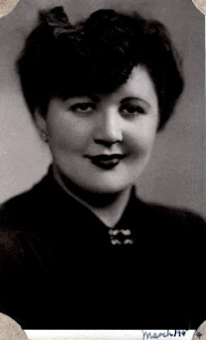

Minnie Sivia Silver

1923 - 1999

How it all started
The Royal Navy was founded in 1546 by King Henry VIII. England had informal Naval forces centuries before this. Scotland had its own Navy long before England in the Middle Ages. The 1707 Act of Union linked the two Navies.
My Uncle Jule tells the story of my grandfather and the history of becoming an officer in the Royal Navy. This dates back much further than anyone would have imagined in fact Jews in the Navy were around even as far back as 1760 probably earlier. One of the first Jews who actually became an officer and Captain in the Navy was Sir Alexander Schomberg (1720-1804) in fact he was a son of a Jewish doctor and lived in England. He was a Jew by birth, but due to the Test Act of 1673 he had to give up being Jewish and adopt the Church of England to continue being an officer in the Royal Navy. This he did at the age of 23 which was late at the time. Because of the Test Act his whole family abandoned Judaism.

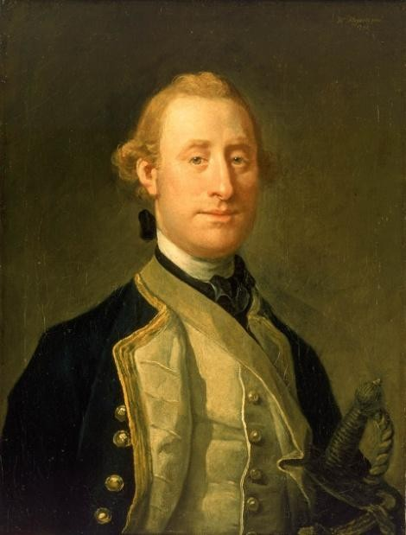

Captain Schomberg's painting is still owned by the National Maritime Museum Greenwich London. It reminds me so much of the story of Benjamin Disraeli (1804-1881) who became Britain's prime minister. Benjamin ‘Dizzy’ Disraeli was the son of Isaac, a Jewish Italian writer, and had an Anglican upbringing after the age of 12. With Jews excluded from Parliament until 1858, this enabled Disraeli to follow a career that would otherwise have been denied him. He was Britain’s first and so far, only one from a Jewish heritage to become Conservative Prime minister. If you ever go to his home at Hughenden at Beaconsfield, Buckinghamshire, England, you can almost feel the great man's presence. I felt that most of all in his study.
In the 1980's I started to take a keen interest in my grandfather’s life. I started by visiting The Imperial War Museum, Lambeth London and was granted access to their vast library. My ex-wife, Amanda, was very supportive and a big help. That continues to this day with her involvement in this book, I am delighted to say. At the Imperial War Museum, I found other documents and a photo of H.M.S Minerva which we did not have in our possession. I also visited The Old Royal Naval Collage at Greenwich
London. There I stood in this magnificent Great Hall where my grandfather had dinner with the other Officers when he attended the Naval Collage. Perhaps even with H.M. the King when he visited. I also visited the beautiful Chapel at Greenwich. It was wonderful to be in a place so important to his life. The Old Royal Naval Collage Greenwich connects us to our past history of the Royal Navy brilliantly.

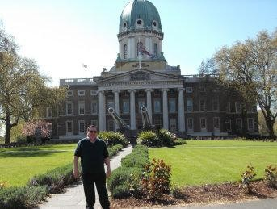

The Imperial War Museum London. I had done my
original research there in 1980.
In 1999 both my Uncle Jule and then three months later my darling mother Minnie Silver passed away! All my mother’s treasured documents and photos passed to me and a copy of Jule’s brilliant Life text. In their memory I created my first Life site online in 2000. I still have it and it has grown immensely. I have never lost the passion for it ever.


Alan Derek Bright
1947 - 2015
My late cousin, Alan Bright, became its greatest supporter and contributor. He loved the thought of his grandfather's Navy career being a success! I adored Alan, he and I shared this massive deep sense of pride in our grandfather's achievements, but also in Alan's own father Burly Bright. Burly really continued his father's success in many ways. As this wonderful story unfolds you will see how and why. Alan would say “that looking at my Life site he would get misty eyed”. The memories of all we loved and lost are there. It’s always been that way with me as well. My other cousins have been supportive over the years. Adding intellectual additions and information. Particularly Philip and Graham Bright. They are the sons of Valerie & Jule Bright. I have often looked to their feedback and wisdom to improve the Life site I created online.
I got the opportunity to visit Portsmouth a number of times over the years. Aboard HMS Victory, I stood with great sadness near the spot Lord Admiral Nelson passed away. For me he represented all you can aspire to be in the Navy. Great at planning and a master tactician was the cornerstone of his brilliant leadership. His life was just as fascinating, and he was almost treated with a rock star status. To me he is the greatest of Britain's heroes and we have had many over the years. The technology of War has changed. However, the quality of the way a ship or fleet is run can make a big difference. The training and expertise of the crew are everything. No one person is perfect, but I like to think of my grandfather doing his service in the same proud way as Lord Admiral Nelson. I think that's true of most if not all that serve in our outstanding Royal Navy, even today. A wonderful statement came from the Carl Von Clausewitz a Prussian general and military theorist. “War is the continuation of diplomacy by other means “. Sometimes our governments have had little or no choice, but to go to War.
How does anyone really start to tell this story? This one is not fiction, but a story of a life. My grandfathers, Morris Moss Bright. In telling his story, it is also a wonderful thing to be able to tell his family’s story as well. This is also a life that took place in a time when the free World fought for survival. Not once, but twice! Two World wars would redraw the map of the World.
Britain has opened its arms to many people from all over the World especially in the early part of the twentieth century. It still does to this day, but has found this overwhelming and is cutting back on immigration. Like America it became a refuge of safety for many. Although it was not always safe all the time here. Crime and poverty were just a part of everyday living on the streets of London. However, compared to the pogroms of Russia against the Jews (Anti-Semitic attacks by the state ending in death, and destruction of property). Britain was a place to live, learn, and prosper. There was freedom to practice religion and a chance to better oneself. There is so much to be proud of about Britain.
There is no doubt in my mind that Britain has done a lot of good around the World. Many are ready to criticise Britain! Not me I am all for us, the British. That makes me patriotic and grateful. This is a brave nation. Standing quite often alone against evil in two World Wars and many others. With the good inevitably comes an awful mistake like Slavery in the past and Windrush in the twentieth century (immigrants were classified as illegal). At least nowadays, we realise these historical misuses of power and adopt diversity and equality as a modern nation. I believe that is the right attitude. Because of that, my ancestors were able to settle here.

A changing World.

The World was about to change dramatically in the early 1900’s. In those days Great Britain was a vibrant World leading power. It had a vast Empire and resources. Britain was considered as “the empire which the sun never sets” approximately 25% of the Earth’s population was under British control. The British Army was at War almost constantly and as the century turned it found itself in a ferocious War against the Boers for a second time in South Africa. The Boer war went on until 1902. This War was brutal and cost 22,000 British and Imperial lives! The British government had paid £210 million (25 billion in today’s money) to fight it. A War on a scale that had never been seen before was coming! It would engulf most of Europe and be fought across the globe. The First World War was an industrial technology War fought with weapons that had never been seen before.
Our Navy ruled the seas as it had done for over 200 years or more. The Jews of London, unless wealthy, which the majority were not, lived and worked in and around the East End. Those streets were hard and were full of crime and risk. They also represented freedom and opportunity for many.
I want to take you back to the year 1839.

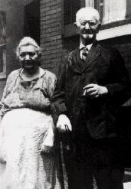

Gershon & Rebecca Rosenthal

An important year in this story. This was the year my great-great grandfather on my mother’s side, Gershon Rosenthal was born in Poland then a part of the Imperial Russian Empire. Rebecca Emanuel his wife in later years, and was born in 1843. Rebecca would give birth to eight children. Quite a lot by any measure. They had very big families in those days! By the 1870's the couple had emigrated to London, England.
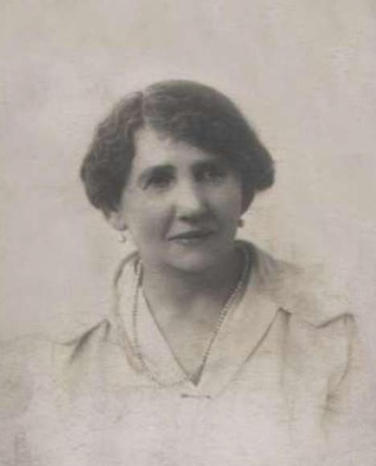

Anne Brightman
1872 -1958

Anne Rosenthal was my great grandmother, and was born in Bethnal Green London in 1872. She married a man called Samuel Brightman (Morris’s father) sadly he passed away in 1902. Morris was born on 9th August 1890 in the East End. The family were poor and I expect life was hard for them. Morris's mother Anne Brightman (nee Rosenthal) had 5 children. Morris was the eldest. Anne was not what I would call an Orthodox Jew, but she definitely went to a Synagogue. They lived in Poplar. At some point the family changed their name from Brightman to Bright. Anne remarried in 1904 to Barnet Ginsberg. Sadly Barnet ‘s daughter, Julia Ginsberg died due to a very bad fire at the Topical film studios in Wardour Street London in 1924!

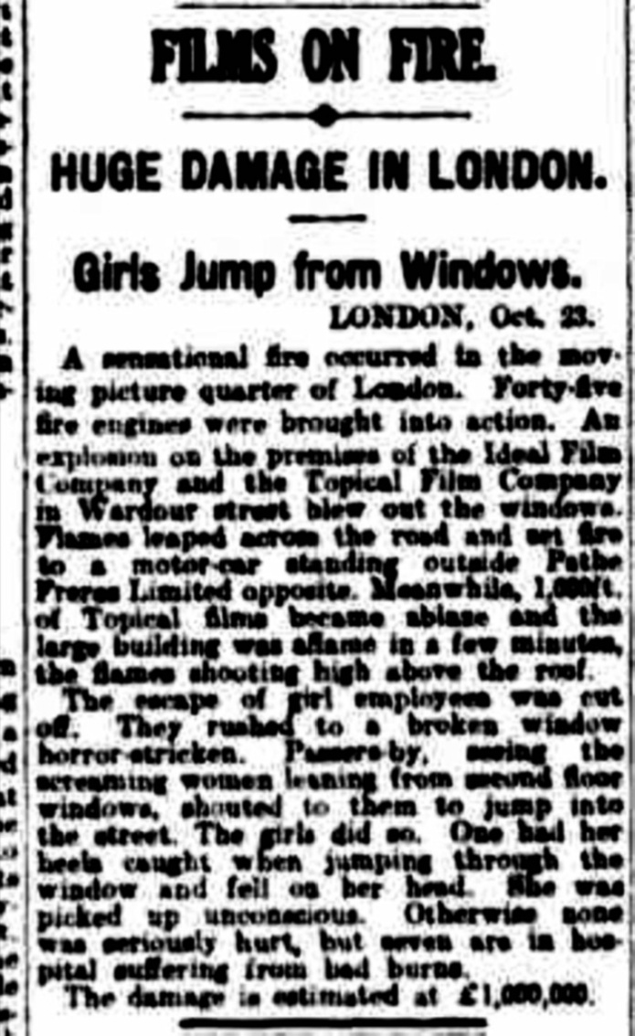
Rare news clipping about the fire.
My thanks to Graham Bright for
finding this!

Morris as a young boy liked to walk by the docks and see the many ships. He was rumoured to have had a conversation with an old sailor. This person must have convinced Morris to join the Navy. In 1905 he lied about his age by one year and then he got his mother to sign the documents to enlist. Anne who could not read or write thought he was joining the Post Office as a telegraph boy. Morris became a boy entrant to the Royal Navy. Morris originally signed for 12 years’ service. On the entrance form he was confronted with two choices of religion. Church of England or Catholic. He put C of E! When Anne, his mother, heard about this mistake she contacted the Rabbi who then wrote to the Admiralty and requested the religion be changed. However, Morris would still have been expected to attend Church services in the Navy. We know for a fact this happened as my late mother, Minnie, told me her father attended services at the Royal Navy Collage at Greenwich, London as an officer.
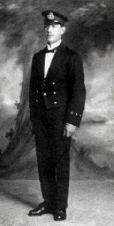
Acting Warrant Officer.
June 1914. HMS Minerva
Joining the Royal Navy at any time is a challenge even today. High expectations, discipline, training and standards are the things the Royal Navy is famous for. The Navy is called the Senior Service for a reason. Even in the early 1900's this was the way the Navy crewed its ships. Going from the streets of London's east end to the Royal Navy’s premier English base, Portsmouth Hampshire it must have an experience in its own right. It was here that the skills you required were taught. The discipline was very strict. There is a mention about holy stoning where the boy sailors had to scrub the deck with a soft and brittle sandstone every day. The Officers beat the boys with rope ends. Standing over them was a Petty Officer. Morris said to himself “I will be like you one day “. The training included periods at HMS Ganges the old training ship. HMS Ganges the year Morris joined 1905 changed from sailing ship to a land base known as a stone frigate. The food was horrendous! Ships biscuits and pickled Pork from barrels where the food had gone off! It was a tough life. The Navy was changing too and evolving from a Victorian Navy to a more modern fleet. However, many traditions still existed of training and discipline. The best one had to be the daily tot of rum. The tot of Rum mixed with water started circa 1655 this tradition ended in 1970. The Navy had and still has many duties and functions to perform. The square bashing and marching would have been relentless. This was required for Ceremonial duties and for discipline in the massed ranks. The British services have a fine tradition of marching. I like to think we are the best in the World.
Morris's early years with the Navy also included being posted to four ships. HMS Euryalus, 1906, HMS Repulse, 1906 and HMS Pembroke, 1908 and HMS Falmouth, 1911. In the following years Morris saw service at a number of shore bases to learn more skills. From 1906 he started to rise through the ranks. Boy 1st class, able seamen, leading seamen, Petty Officer. In 1911 Winston Churchill became First Lord of the Admiralty (a political appointment). He wanted able men from the lower decks to have the opportunity to become an officer in the Navy. It was quite unusual for a Jew to hold rank. This was different in the Army, where Jews had been successful at achieving high rank. Many before Morris had to change their religion to become an officer in the Navy. This did not stop Morris at all in fact. It seems like this drove him to succeed. Morris was proud to be Jewish everything he did especially in later life shows this as I will explain later on.

However, his deep devotion to the King, the Royal family and Royal Navy was just as important as being Jewish. Like many including me, British first and everything else second. My mother wrote in later years and told me of having to stand for the National anthem on all occasions. It is a tradition that I do to this day, in honour of my grandfather and mother. Most of all it’s the same adoration and loyalty I feel to our King Charles and our Nation.
Alec Guinness in the movie Lawrence of Arabia as Prince Faisal said a very famous line during a conversation with Lawrence. They were discussing England's ability to strike at enemies.” Because it has a Navy. Because of this, the English go where they please and strike where they please. And this makes them great. Right.” Although this is a line from a film, it was true Britain projected its power across the World. Very true and important words. Even today our great Navy stands ready to strike evil down across the World. They just need a few more ships that work!
In June 1914 Morris was promoted to Acting Warrant Officer. In July 1914 he was appointed to HMS Excellent & Vernon these bases had a focus on gunnery. Later that year he was appointed to H.M.S Minerva. She was very much a ship from the Victorian Navy, but she was well built. In 1903 long before Morris went aboard. She escorted Captain Robert Falcon Scott’s ship the Terra Nova, on his South Pole Expedition. Minerva's very name was iconic and it had served the Navy since 1759. By the time Morris was appointed to her, this Minerva was already 17 years old, but she could pack a punch along with her sisters. Her class was Eclipse class protected Cruiser and she was built and launched 1897 at the historic dockyard at Chatham, Kent, England. Some of our greatest and most famous Warships were built there including H.M.S Victory. Minerva was no exception.

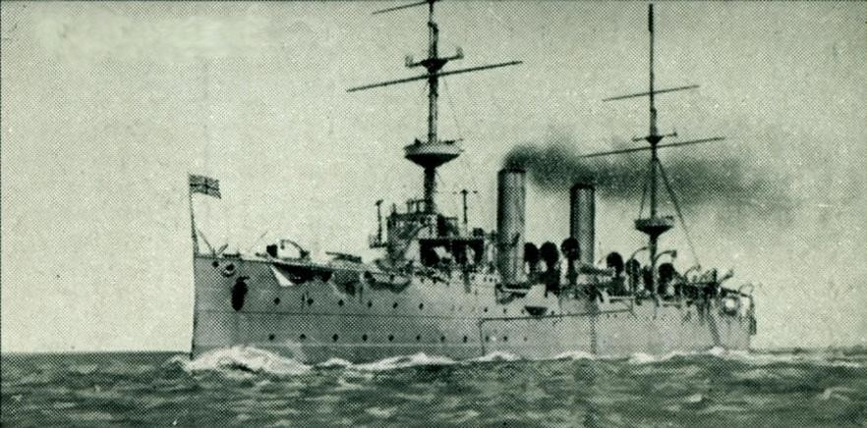

HMS Minerva
By the time Morris was appointed, Minerva was being made ready for War. Her exterior colour went from black to a more camouflaged neutral colour. This would make her less of a target. Fate and hindsight are a surprising thing. Out of all the ships Morris could have been assigned to, Minerva was one of the best. Minerva had a compliment of 450 men. Things must have got a bit cramped at times. No air-conditioning in those days and of course she was fuelled by coal. The engineers and men coaling the ship must have had a hot hard job. It’s easy to get lost in the romance of H.M.S Minerva, but I have to remind myself that she was a ship of war and not a cruise liner.
H.M.S Minerva would see action right at the start of World War 1. Britain declared War against Germany on 4th August 1914. In October of that year Turkey joined Germany as an ally. The main reason was Turkey wanted money and Russian territory. The Ottoman Turkish Navy was a force to be reckoned with in 1914. The Ottoman army was originally 150,000 men, during the course of the War that became around 2.8 million.
Aboard H.M.S Minerva, Morris's main responsibility as acting WO was to act as a channel between the non-commission ranks and Senior Naval Officers. This was to enable communication between the sailors, and marines. This would include Senior Navy leadership. Quite an important position. My late mother, Minnie kept many of the reports on Morris's performance. They show that Morris was a competent and organised officer. However, gunnery would have been his prime concern. Preparing the ship for battle.
H.M.S Minerva was part of the 5th Cruiser squadron. In September 1914. There were a few events that I will explain shortly, but the big one was the shelling of Akaba Fort and barracks on the Red Sea. At 5pm, 1st November 1914 and 2nd of November, Minerva Fired 6 rounds each time! By 1915 The Allies had quite a battering at the Dardanelles, Turkey. During that battle Royal Navy ships were sunk by the Turks. There is no doubt they were a formidable country to fight. In 1914 all this must have seemed unthinkable, but that is the ever-changing nature of War. After H.M.S Minerva's shelling came the landing. Morris commanded one of the landing parties. Later on, he described the action to the Jewish Chronicle. He described Akaba as “mud huts and a fort “. It is hard to believe that Akaba would have such strategic value by 1917. Today it is a beautiful historic and tourist destination. My Uncle Jule visited the Fort many years ago. He said you could still see the holes Minerva's shells made! Morris got permission from his Captain and sent it to the Jewish Chronicle. This is the letter about the bombardment of Akaba. I felt as he was there his description was far better than anything else I could write or add.

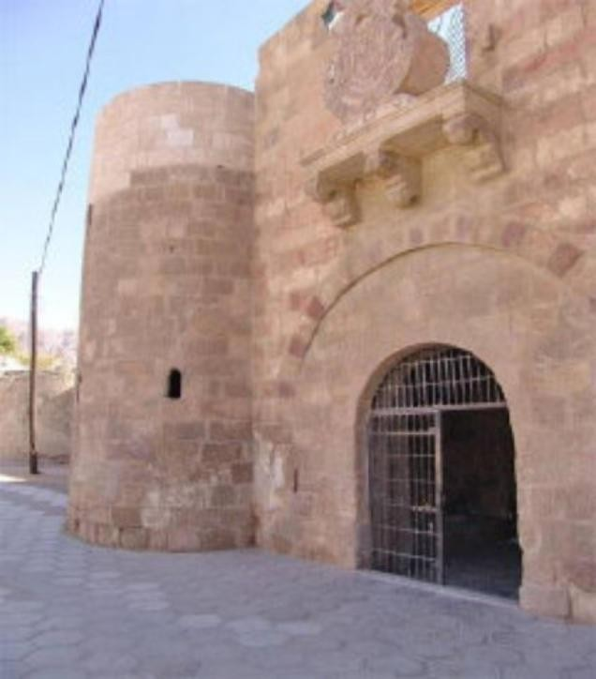
The Fort at Akaba today.
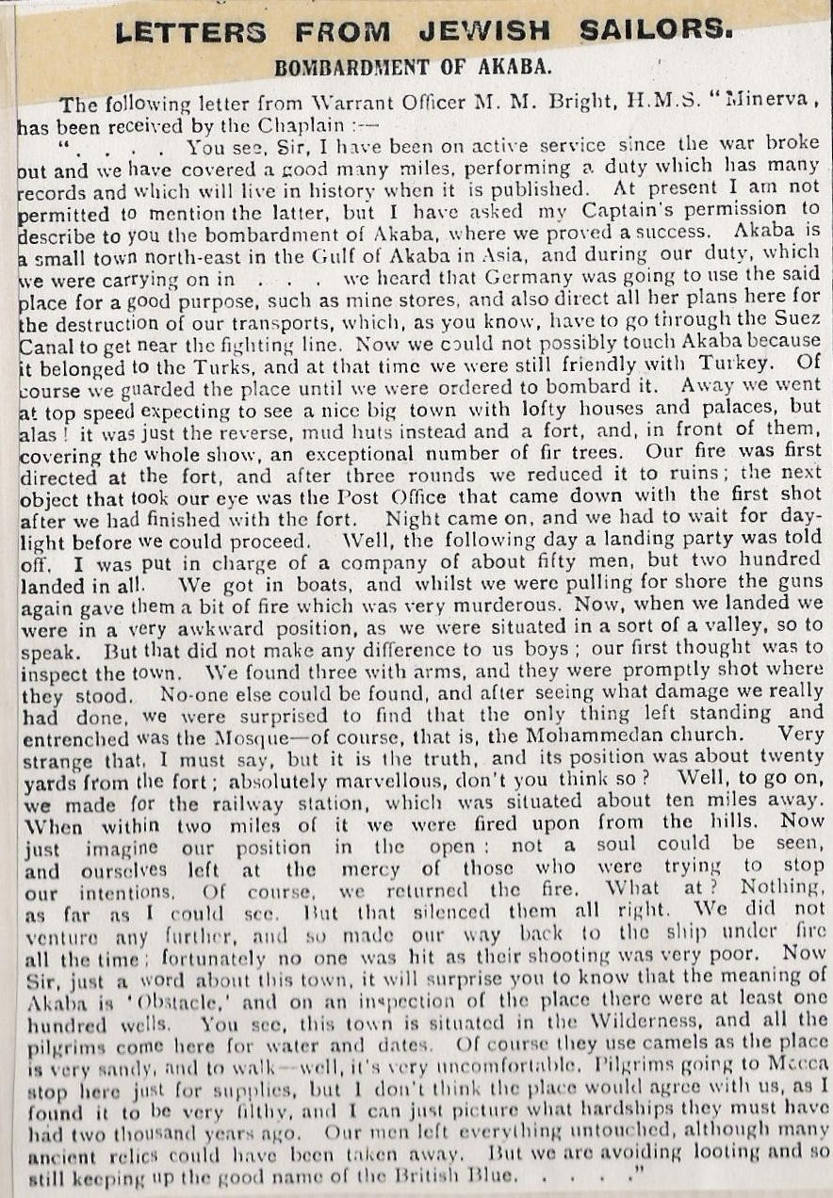

In 2007, I visited Eilat in Israel. Sitting on the beach I could see Akaba and it was one of those moments. I could imagine the action there taking place. I think it's important to explain about Akaba. Today it is part of the Hashemite Kingdom of Jordan. By 1917 the Turks had built great guns. This was to control the Red Sea. By controlling the Red Sea this would restrict British shipping. Major T.E.Lawrence and King Feisal’s Arab army crossed the Nefou desert and attacked Akaba from the land side. This was a spectacular piece of military genius. This action made Lawrence quite rightly a national hero. H.M.S Minerva got a mention in T.E.Lawrence's book the Seven Pillars of Wisdom. She would have had a role securing Akaba after its capture.

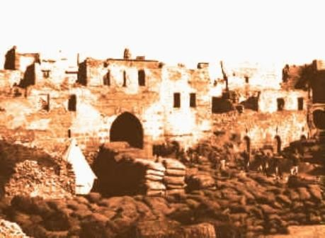

Akaba Fort around the time of the
bombardment by HMS Minerva.

Here are some of the events that happened to H.M.S Minerva. She was originally attached to 6th Destroyer Flotilla in 1913 and was at Portsmouth until outbreak of war. For a short spell she was attached to the 11th Cruiser Squadron in Ireland in August 1914, but joined 5th CS in September, capturing an Austrian merchantman off Finisterre the same month. The story goes there was a female spy aboard that ship. Then Minerva sailed to Suez Canal in November 1914, and then on to the Dardanelles November 1915; Minerva was involved with the running aground and sinking of the Turkish torpedo-boat Demir-Hissar off Chios on 17 April 1915. The main ship involved in that action was HMS Blenheim.
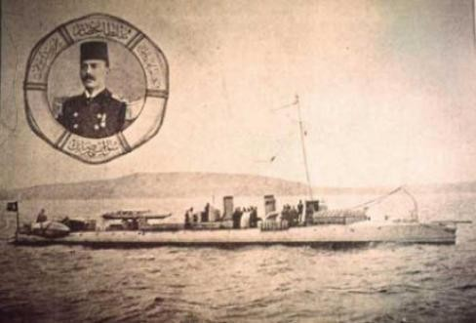

Turkish torpedo-boat Demir-Hissar

World War 1 raged on with some of the most horrendous suffering humans can inflict on each other, at sea, on land and in the air. Minerva's patrol duty was mainly around Suez and East Africa. The ship avoided the very worst of it. However, the Middle East was just as volatile as it is today. Africa although a side show to the main fighting in France was still important. The war at sea was very much affected by the war on land of course. In Jule’s life text he writes about a German officer Colonel Paul Emil Von Lettow-Vorbeck (1870-1964). In 1914 he successfully invaded part of the British Empire and repelled a British landing at Tanga (Tanzania). He did this with 3000 Germans and 11,000 Askari (indigenous) Africans. In Jule’s life text he is called Von Latto. I suppose this was a nickname. It seems that he was the British number one target on land. Just like Lawrence of Arabia showed what could be achieved with a small force, so did Colonel Vorbeck.

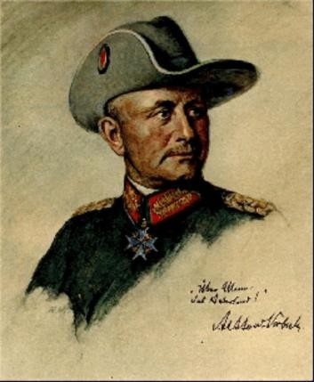

Colonel Paul Emil Von Lettow - Vorbeck. Outstanding German
Commander in Africa.

The German Navy had a very famous and versatile ship called the SS (His Majesty's ship) Emden. Built in Danzig in 1906 and completed in 1909. She was a Dresden class light cruiser. Armed with ten 10.5cm (4.1inch) guns and two torpedo tubes. Captained by Karl Von Muller and his superb crew. She is a story in her own right and many books have been written about her. During the early part of the war, she sunk 21 ships. The Emden was known as the “The Gentlemanly raider”. This was because she treated captured enemies with due care. She was able to disguise herself as a British battleship by adding a false funnel. This enabled her to have an element of surprise. H.M.S Minerva would have been alerted to Emden's importance and she was mentioned by Jule in his text. The Emden was finally disabled and run aground by HMAS Sydney off the coast of Cocos Islands on November 9th 1914. Much of her crew was taken prisoner, but they had sent a landing party ashore before the battle. They made it all the way back to Germany. Says a lot about them really. Where Morris & Gertrude are buried in Edmonton London there is a gravestone behind their grave. The name is Emden. It seems my grandfather finally caught up with it!

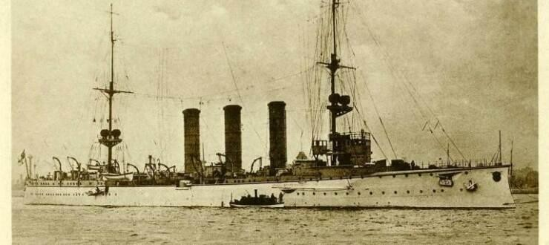

SMS Emden. The image below shows her
beached by HMAS Sydney.
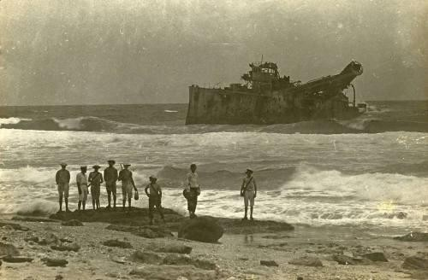

In 1916 there was a sea battle that would transform the way the Royal Navy would evolve in the future. The statistics of the battle of Jutland near Denmark to this day are absolutely frightening. Germany had worked long and hard on what was important in making a modern fleet. The British Grand fleet relied on pretty much the same signal system that Nelson used at Trafalgar. The Germans had concentrated on gunnery as well. They also used more advanced ship to ship communication.
Morris was very lucky missing this battle it is because of the scale of loss of life! The British lost 6,784 and Germany 3,039. Compared to the Battle of the Somme on land in France. British 100,000 plus and Germany 300,000 plus. This loss of life at Jutland is small by comparison!! However, for Britain it was a shock and wake up call. The Grand fleet recovered and there was never a battle on Jutland’s scale again in WW1.
History and hindsight are a wonderful thing. At the time the Commander of the British Fleet was Admiral John Jellicoe. He was criticised terribly for not delivering the knockout blow against the German fleet. I disagree and believe he was right to save the fleet. His correct decision saved many British lives and he was able to blockade shipping lanes. Ultimately causing the German grand fleet to never ever go to sea in the same way again. The decision helped Britain win the War.

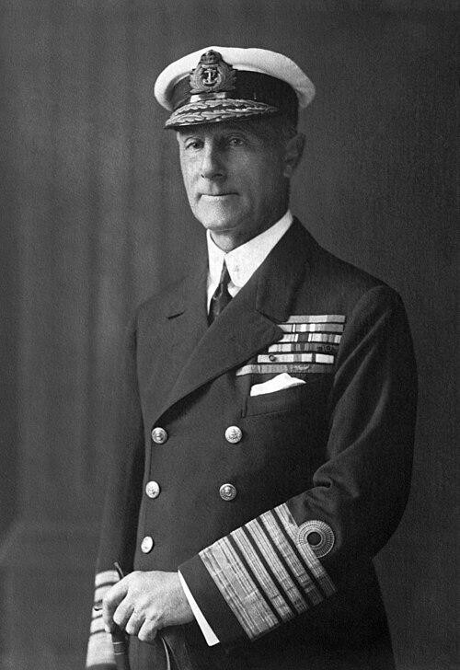

Admiral of the Fleet .The Right Honourable
The Earl Jellicoe
GCB OM GCVO SGM DL 1859 - 1935

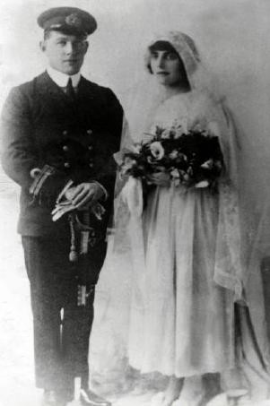

In 1918 Morris married my grandmother Gertrude Golda Wisberg. This took place at Dukes Place Synagogue in London. The bride and groom left the wedding under an arch of Navy swords, which is a military tradition. The photograph I possess shows Morris dressed in full Navy uniform at the rank of Lieutenant. My grandmother was very lovely in many ways. I can never forget my late sister, Gloria Zadek saying one day many years ago how beautiful our grandmother was!
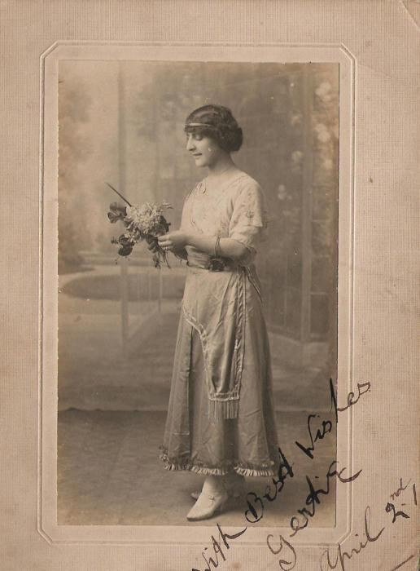

During the First World War Gertrude sent photographic postcards of herself to Morris. They are some of the best and most flattering images ever taken of her. This is how sweethearts stayed in touch during the dark days of the Great War. If the Navy gave Morris a life at sea. Gertrude gave him a truly marvellous family and life ashore. The photos I have shown such a deep love between them.

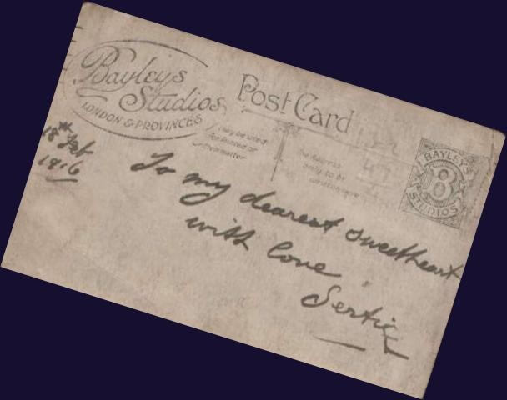

Gertrude came from a successful family. Her father was also called Morris and mother Minnie. He was a Turkish cigarette blender. Most likely they originally came from Turkey. There had been a terrible War with Greece in 1897. The family at some point relocated to Odessa then a part of Imperial Russia. Why Odessa? Makes sense if you are in the cigarette business Odessa was and still is an important seaport. However, being a Jew in Czarist Russia could not have been easy. There was great hatred of Jews (sadly this has not changed) eventually they moved again! This time to England. Some of the photos in my possession were taken in Newcastle upon Tyne. At that time Newcastle would have been a tobacco producing area. Newcastle is on the River Tyne giving access to shipping as well.
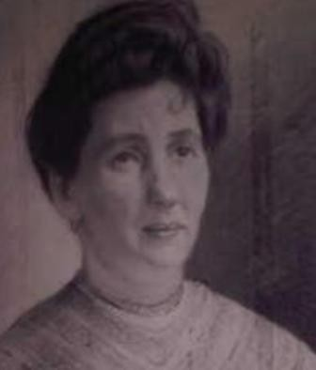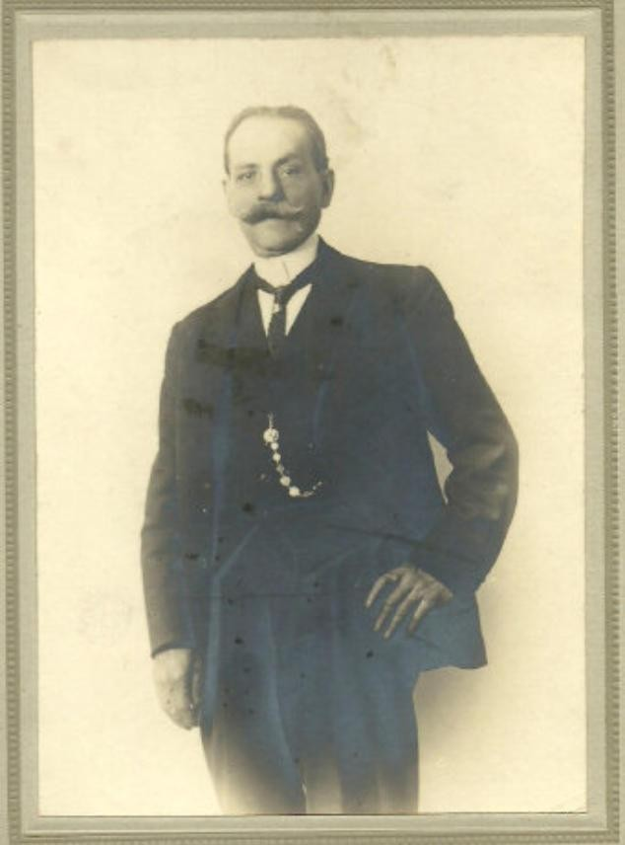
Minnie Wisberg
Morris Wisberg
1861 - 1920
1855 - 1929

How long the family stayed in Newcastle I am not sure. At some point they relocated to London. Morris & Minnie Wisberg had a vast family. I have researched as much as possible, but Morris had thirteen children! Most of that information came from Morris Weisberg’s actual gravestone in Edmonton London. Were they all from one women Minnie Wisberg? I am not sure. We know that both Gertrude's brothers Philip & Geoffrey served in the Army. Wonderfully they both survived the Great War. We do not know for sure if Gertrude's family had money. It is likely because the address gives it away. Hampstead Road, London.
Morris and Gertrude were truly blessed with three wonderful children. The first was born in Paddington, London in 1919, Cecil Burlington Bright (known by all as Burly). Followed by my mother Minnie Sivia Bright in 1923. Finally, Jule Warwick Bright in 1930. Each were gifted with different qualities, but they all shared Morris's pioneering spirit. Looking back, I can truly say that Morris and Gertrude would have really had great pride and pleasure in them. It would not be possible to tell Morris’s story without including them.
The First World War finally started to come to a close in 1918. Morris did a spell as a Lieutenant aboard H.M.S Marlborough. This was a battleship of the Grand fleet. Then in 1919, H.M.S Pembroke this most likely was renamed from H.M.S Achilles an actual ship. After the War ended, he continued with his studies at the rank of full Lieutenant. He studied at the Naval Collage in Greenwich. Jule also thought he attended H.M.S Dryad navigation school around this time.
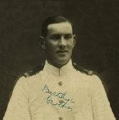

Lieutenant Bright
Wearing tropical white uniform

My grandmother Gertrude was disenchanted with his long absences from home. After fifteen years of Navy service Morris finally retired in 1920. He retired as a Lieutenant, but was promoted retired to Lieutenant Commander later on. He still remained on the Navy active list.
At the grand age of 30 there was much that lay ahead. Morris's siblings were moving and travelling abroad. He had a brother called Daniel Bright who was a boxer. He was known as Alf and had 450 fights. Daniel started at a young age and boxed for 27 years he ended his career in 1929. In the early 1920's he went to America. His career was going well and was being lined up for a fight with the great Gene Tunney. This would have given him a shot at the heavy weight championship of the World title. Sadly, an event would wipe this out! He saved two children from drowning in the river Dee here in England. This cost him his sight for two years in both eyes. One eye the sight slowly returned. I have always thought of him as the champ and to me he is a hero. Some things are not meant to be.

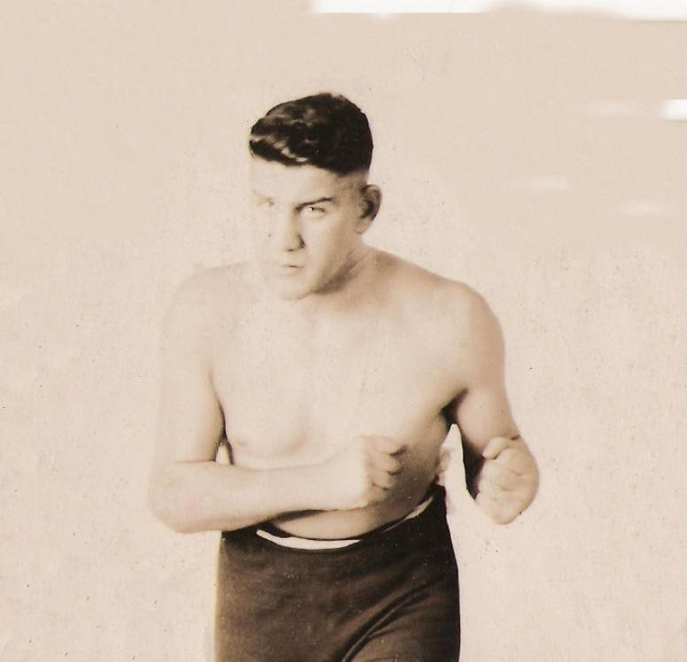
Daniel Bright
Circa 1897 - 1960

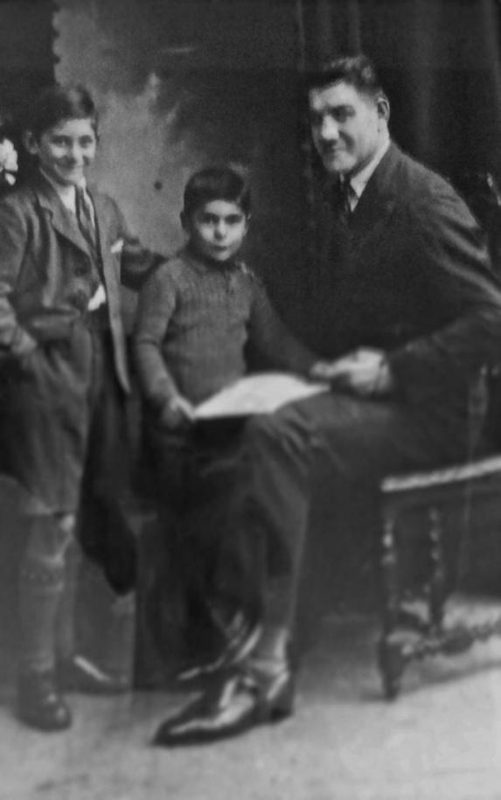

Daniel Bright with his sons. Cecil
(left) and Walter.

Daniel had two sons Walter (known as Wally) & Cecil. Cecil born circa 1920. He was 6ft tall at 12
years of age. During World War 2 he joined up as a territorial rifleman in 1939 and was demobilized in
1945. Like many he did his bit.
I met both Wally and Cecil at family celebrations many, many years later. I do not really know much about Wally and I'm sorry to say I can't seem to find much about him either. Cecil Bright was different because his daughters sent me a newspaper article about her father and I was able to find out a lot more about him because of that.

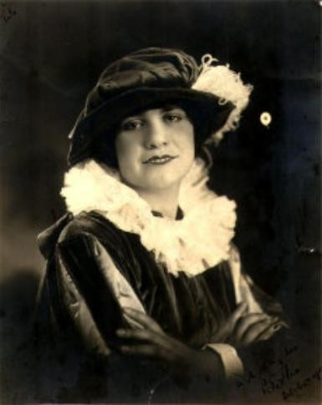

Bertha Bright Knapp
1899 - 1954
Morris had two sisters who emigrated to America. Bertha Bright Knapp (nee Bright) lived in Grosse Pointe Township, Wayne, Michigan. She in fact spent some time singing with the Doily Carte opera in London. But eventually she went to live in America and that would have been the early 1920's.

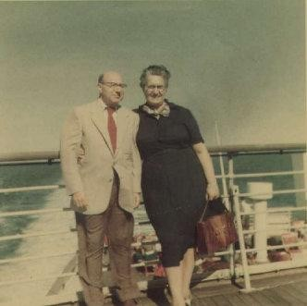

Leonard & Rose Bright.

1894 - 1969 1894 – 1979

Aboard the SS France 1960’s

Rose Bright also went to live in America and she lived in Green farms, Connecticut. She married her cousin who was called Leonard Bright. Rose had a large family. Rose visited London when I was a small child, but I know that there were other visits where she visited England. My grandmother, Gertrude went to visit her in the USA probably in the late 1960's. I have a photograph of Rosie and my grandmother, Gertrude, together there.
Jule describes “the years between the wars were nearly as eventful as wartime”
Morris had been successful in the Navy, but when he came out of the navy, he started to do other things. Jule describes “him turning his hand to almost anything to make money”. Within a year the severance pay had been spent on various schemes. Morris and Gertrude had a wet and fried fish shop in Hampstead, London. The premiere fish that they sold was called the bloater (herring) and the bloater was a fish that was apparently quite popular at the time. I have actually got a photograph of the display in the shop.

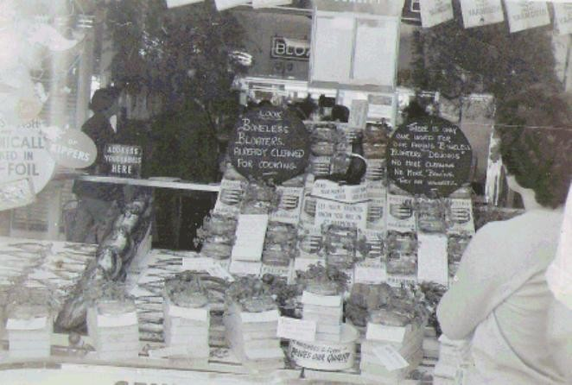

However, Morris and Gertrude’s shop was short lived. One evening they went to the theatre and unfortunately in their fish shop there was, I suppose, quite a strong smell of fried Fish. Somehow this had got on their clothes. If you're around fish all day long, I suppose you don't quite notice the smell on your clothes. People around them could smell the fish! I expect that was quite embarrassing for them. I think that was one of the reasons they gave up on the fish shop. It became a fruit and vegetable shop instead.

Morris also had a cartage or conveyance business. I know that he did that because we have a telephone directory from 1926 and that's how this is listed. Morris bought a lorry and secured a contract to cart Paderewski’s piano around the UK, when he was on tour here.

Morris became busy with the Jewish Friendly society movement and became President of the Tree of Zion Lodge in the order of Achei Brith and the shield of Abraham. During the early 1930s the World started to change yet again quite dramatically! Anti-Semitism again was becoming very rife everywhere in the World particularly in Nazi Germany. Not only there, but also in England. The Fascists were led by Oswald Moseley; he founded the British Union of Fascists in 1932. In 1940 he and his wife were imprisoned in Holloway Prison as a threat to the security of the nation. Morris was a forceful speaker in the platform of the anti-defamation committee and he was often to be heard at Speakers Corner Hyde Park London in their fight against the fascist element that started to raise its ugly head.
Morris's looks helped; he was fair haired with blue eyes. His powerful voice was an asset to his public speaking. Some of his friends at the time were Major Lionel Rose Frank Costin and Frank Renton all were outstanding fighters against Mosley and spoke all over London at street corners opposing the fascists wherever they were. There is still a Lionel Rose prize for public speaking today.
No one could have imagined the fate of the Jews of Europe at the brutal hands of Nazi Germany! In later years we would get to find out the truth. German Nationalism had thrown off the shackles of the agreements made at the end of World War 1. Then Germany started building up her forces throughout the 1930’s. Air, sea and on land Germany prepared for War again.
Morris started to have an interest in refrigeration. He thought this was an up-and-coming market. The fridges in those days would quite often break down. Morris went into the repair business. Later on, he started selling them and small cold rooms. He would eventually be joined by Burly. My Uncle Burly turned out to be an entrepreneur of surprising proportions. Burly’s story is as exciting and fascinating as his father's. Burly did an apprenticeship with Kelvinator. The business was doing well and in 1937, Morris and family moved to Park Avenue North, Willesden, London.

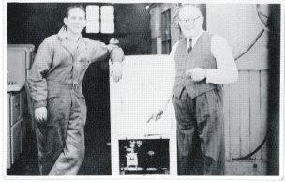

Burly and Morris
Started repairing refrigerators

World War 2 back in the Navy.

King Edward VIII wanted to marry Mrs Wallace Simpson an American socialite, in 1936. Mrs Simpson was divorced from her first husband and was divorcing her second. This caused a constitutional crisis. In December of that year, he abdicated the throne. He was then known as His Royal Highness the Duke of Windsor. He visited Germany in October 1937. Historians believe he had dealings with the Nazi's. This was lucky? For Britain!

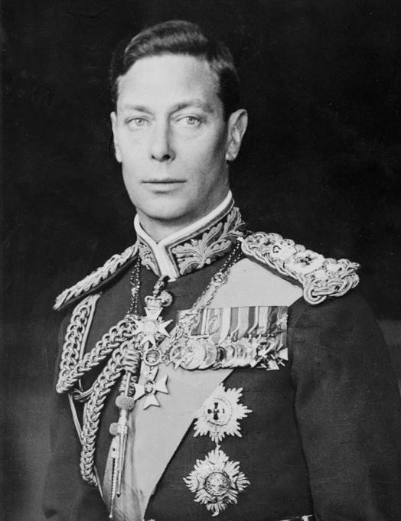

His Royal Highness the Duke of York (1895 – 1952) known to his family as “Bertie”, became King George VI. What a great King and fine man he was. Overcoming a difficult speech impediment. He was the right King that the country needed during desperate times during World War 2. He could never have imagined his daughter Elizabeth would become the longest reigning Queen in British history 70 years 214 days H.M 1952 - 2022).

Britain was sadly forced into War in 1939! Nazi Germany's hunger for land and power spilled over its own borders and they invaded Poland! Britain was Poland's ally and declared War against Germany on 3rd September 1939.
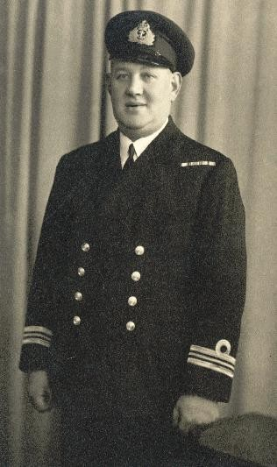

Lieutenant Commander Bright - 1939

In June 1939 Morris was asked to inspect fishing trawlers to see if they could be used as Minesweepers. Morris had attended courses and was kept up to date on Naval advancements over the years. Although Britain was ill-prepared for War, we had many that had served in their younger days in WW1. This experience and knowledge were invaluable to help secure the Nation. You need luck in a War as well as all the right tactics. One of the most incredible appointments had to be the superb Sir Winston Churchill as our Wartime Prime Minister. Volumes have been written about him. There is no doubt the difference an exceptional leader can make.
Shortly after War was declared. Morris was returned to active service at the age of 50! His role in this War would be very different to WW1. In this War he would command a Flotilla of mine sweepers, spend time at the Admiralty, London and be awarded the DSC for outstanding zeal and whole hearted devotion to duty. Later on, he was promoted to Acting RN Commander Equivalent to a Lieutenant Colonel in the Army.
Jule wrote “that a day after War was declared Morris was posted to Harwich. My mother and brother took him to Liverpool Street Station and tearfully saw him off “The following weekend Burly suggested that they would motor up to Harwich”. At the docks they were told he was at sea and would not return until early evening. When the Flotilla did eventually arrive, they were amazed that Morris had gone to sea wearing a lounge suit, bowler hat and a pair of shoes called spats. There had been no time to get his uniform “.
During World War 2 Morris's family went to War. My mother Minnie decided that rather than become a Wren in the Royal Navy. She would prefer not to be under her father's command and opted for the Army. She joined the ATS and served in the Army Pay Corp at Baker Street London. My Uncle Burly joined the Merchant Navy and became a Lieutenant Engineering Officer. My Uncle Jule joined the RAF as ground crew after the War.

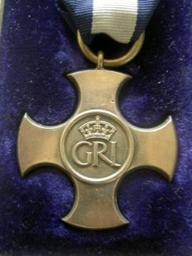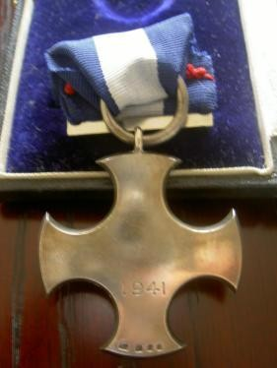

In 1941 came a moment that I and many members of my family will cherish forever. Morris was awarded the Distinguished Service Cross at Buckingham Palace by the King. This was announced in King George VI birthday honours list. The Distinguished Service Cross (DSC) is a third-level military decoration awarded for gallantry during active operations against the enemy at sea. Jule found out the precise reason why Morris received this award. Whilst Morris was stationed at Great Yarmouth, a ship was hit by a bomb during an air raid. The ship was about to sink in the mouth of the harbour! This potentially could have put the port out of action. Morris went aboard with a rating and bunged up the holes with wooden spars and saved the ship from sinking. I am very proud of Morris and the crew for this brave action. This must have been quite dangerous I expect. My grandmother Gertrude and my mother Minnie accompanied him to Buckingham Palace. My mother joked that she wanted a souvenir from the occasion, so she took some toilet paper with the Royal coat of arms on from the ladies! My mother also kept the ticket issued and wrote a letter describing the events that day.

Minnie Bright’s letter of the DSC investiture.
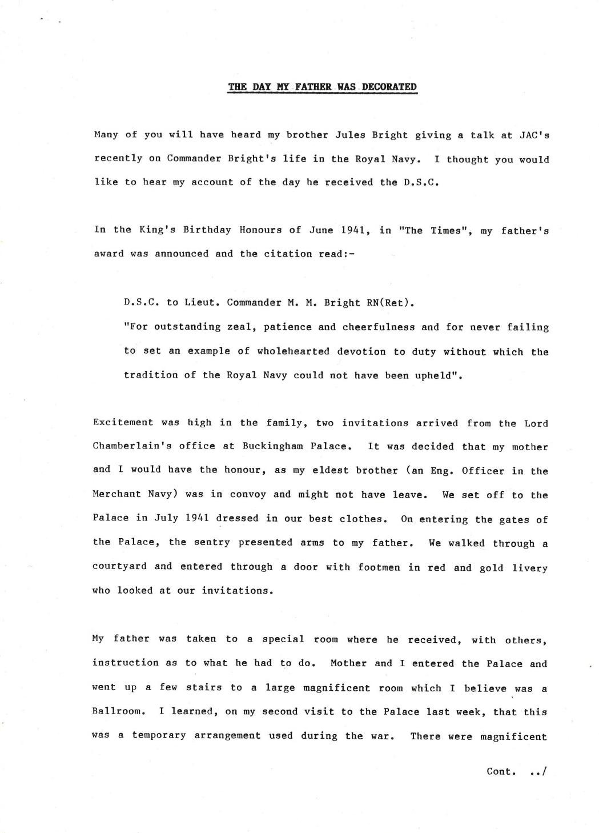

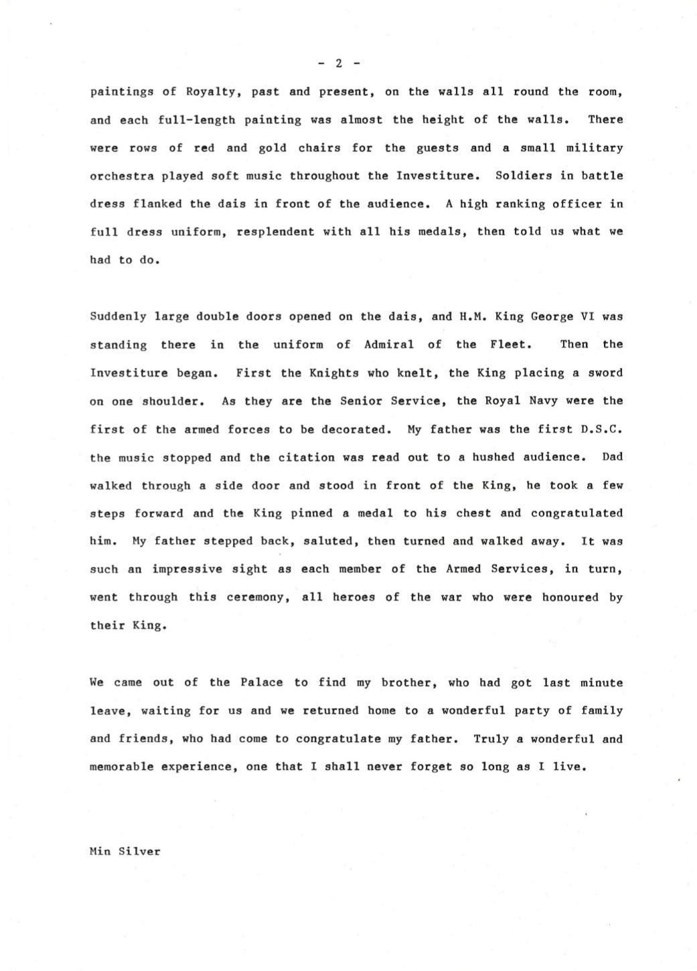

Morris & Burly are outstanding in WW2.

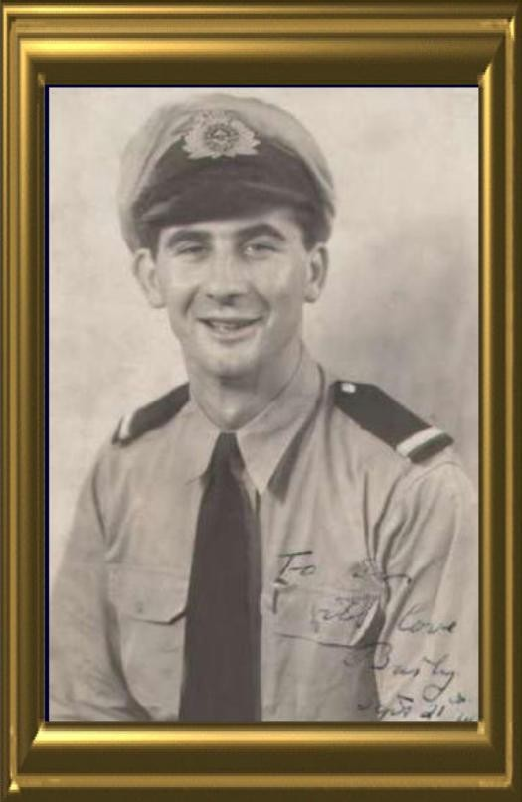

Burly Bright was by this time a refrigeration officer engineer aboard merchant ships bringing meat from Australia and New Zealand. He was aboard the SS Strathallen in December 1942 when it was torpedoed by a German submarine off the coast of Oran. Burly told me that when it sank which took quite a while, 21 souls perished with it. My grandmother, Gertrude heard nothing from Burly for ages. One day she got a knock on the front door at Park Avenue North, Willesden. It was Burly in full U.S Navy officer’s uniform! He had been rescued. It had taken him two weeks to get back after the rescue. Another classic Burly story was one day he turned up at the front door again. This time with a suitcase full of butter! There was rationing during the War! This must have been popular.
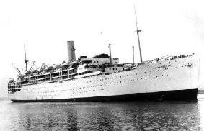

SS Strathallan

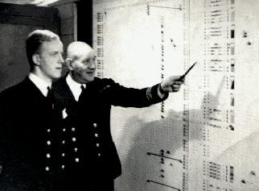

Soon after Morris receiving the DSC, Morris was posted to the Admiralty Minesweeping division next to Horse Guards parade In London. Morris was quite often in the map room when Sir Winston Churchill our great War time Prime Minister would visit. During this time, an officer walked into Morris’s office. After the conversation the Officer was surprised! When Morris asked him “What are you doing for Pesach (Jewish Passover) “The other officer was Captain Fredman Ashe Lincoln QC RNVR. Captain Lincoln had no idea Morris was Jewish! They became good friends. A few years later I was able to contact Captain Lincoln's son who was a Rabbi in New York at the time. It was wonderful to tell him how highly respected his late father was. Sadly, Rabbi David Lincoln retired of Park Avenue Synagogue New York USA passed away in 2024 aged 86.
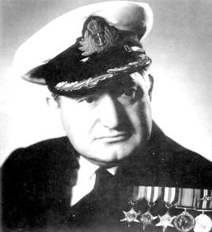

Captain Freeman Ashe Lincoln
1907 -1998

Eventually Morris was posted to H.M.S Cabot, a shore establishment in Yorkshire. Morris by now was in his mid-fifties and the Navy needed younger men for sea duties. Jule wrote about Morris “finding a rating with a Jewish sounding name and sent for him”. He asked the sailor if he was of the Jewish faith and after confirming this, Morris said he had better go to Synagogue for the high holidays in Leeds. The rating said he was not due a pass. Morris gave him one so he could attend. The rating had even more of a surprise when he saw Morris sitting in the Synagogue!
In the Jewish religion it is not permitted to have tattoos (din, law). Not long after joining the Navy, he had one done an anchor and peacock! Morris said from the moment it was done he regretted it. Jule thought that he did it not knowing about the law.
Jule tells, during his text, about visiting Stone frigates (shore establishments) with his father during WW2. He describes the rank Morris held was a wonderful way of life. Officers were waited on hand and foot. Morris even had a batman to prepare his uniform and ensure he looked smart. The officer’s wardroom was like a select London club, pink gins were the order of the day. When Morris was promoted to Commander, the guards on the gates would present arms as he passed. This impressed Jule very much! He recounts at H.M.S Wildfire in Sheerness drinking Nelson’s blood (diluted Navy rum). He describes it as potent and he wasn't surprised the Navy stopped issuing it. You need a clear head to work modern computers and systems.
A few years ago, I wanted to know what it was like to be aboard a Royal Navy ship. I had already been to Navy days at Portsmouth in the 1980’s and had been on a submarine at Gosport. I went to visit H.M.S Belfast which today is a part of the Imperial War Museum London. H.M.S Belfast is a World War 2 battleship. Its size and complexity were absolutely incredible to me. The workshops for making parts for repair at sea, the engine rooms and even bathrooms are on quite a scale. Today the Navy has advanced ships which are massive like the H.M.S Queen Elizabeth aircraft carrier and high-tech destroyers. Although Morris would be shocked at the size of today’s Navy, I am sure however he would be impressed at the technology of today's fleet.

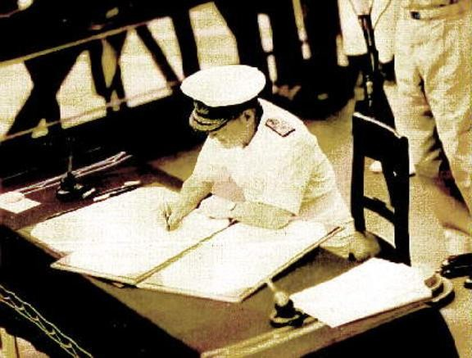

During my early research into Morris’s life, I discovered that he served with an officer aboard H.M.S Minerva in WW1. This officer was a Lieutenant at the time. He became very famous by the end of WW2. Admiral of the fleet Bruce Fraser, 1st Baron, Fraser of North Hope GCB, KBE. He signed the surrender document of Japan on behalf of Great Britain, 3rd September 1945. He had an outstanding naval career and sadly passed away at 93 in 1981. Although Morris never attained this kind of advancement both men were successful.
World War 2 was a very differently fought war to World War 1. There were so many unthinkable firsts that it defies belief that this could really have happened! War is horrid whichever one it is, but sometimes, regretfully, war has to happen. Germany and its Allies had to be stopped! America really did not want another War seeing its forces fighting in Europe again. That all changed with an event that had never been experienced before took place! The attack on Pearl Harbour, Hawaii base of the United States Navy Pacific fleet. The Empire of Japan launched an aerial attack from carriers at sea. 2343 U.S personnel were killed. 68 civilians. 960 missing and 1272 wounded! Seven ships sunk, eleven ships damaged and 151 planes destroyed. In a single action the U.S joined in World War 2. President Roosevelt spoke to the nation the next day: “Yesterday, December 7, 1941—a date which will live in infamy—the United States of America was suddenly and deliberately attacked by naval and air forces of the Empire of Japan”. From that moment on Nazi Germany and Japan would lose the War. By the end of World War 2 Japan would end up paying the ultimate price for its deceit. The dropping of two atomic bombs on Hiroshima and Nagasaki.
Towards the end of the War, Morris was posted to Trincomalee in those days called Ceylon now called Sri Lanka. He had bought his tropical kit, but his health failed. Unfortunately, Morris enjoyed a smoke. I suppose like most people this started at a young age. In those days it wasn't frowned upon quite like it is today. I even have a photo with him smoking a pipe, but he smoked cigarettes mainly. I remember visiting him with my mother at Park Avenue North. Willesden as a child. I can remember the ashtray piled high! The smoking eventually caused lung cancer!

Burly takes Bright’s to the next level

After the War Morris returned once again aged 56 to civilian life. He restarted the refrigeration business in a small way with Burly. The business flourished when Burly started to manufacture Cryostats. These machines could freeze a biopsy specimen very thin. A Doctor or clinician could then view the specimen under a microscope. Burly eventually relocated the company to Huntingdon where it became a world leader in the industry.



The Bright instruments factory
Huntingdon 1990
The heart of a cryostat is the Microtone (which slices the specimen microns thin). This device was invented by Charles Sedgewick Minot (1852-1914). Burly may not have invented the Microtone, but he certainly understood its potential. How proud and thrilled Morris would have been to see a purpose 43, 0000 Square foot factory open in 1990. The company was named “Brights Instruments”. There are quite a few stories that are part of the history of Brights. I visited the first factory in the 70's with my late parents. I remember Burly saying that the Japanese would like to copy his cryostats. They even bought one! Afterwards the Japanese decided it was to expensive to copy the technology. Burly's son Alan joined his father at Brights just as Burly had worked with his father Morris. The years flew by and Burly stepped down as the boss at Brights and Alan became the CEO. Burly even into old age enjoyed keeping his eye on things and worked in the Post room at the factory. Burly was one-day talking to my dad and he told him that Brights had been very successful! In fact, Burly said he could have come to work in a Rolls Royce, but didn't because his workers would have asked for a pay rise. Both Burly and my Uncle Jule had great senses of humour.

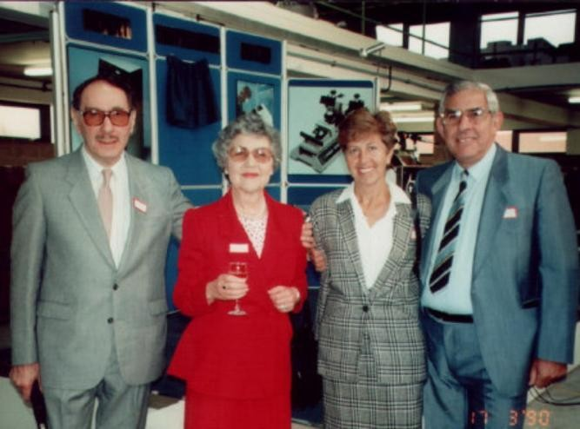

Samuel & Minnie Silver and Valerie & Jule Bright. Attend

the opening of the new factory.

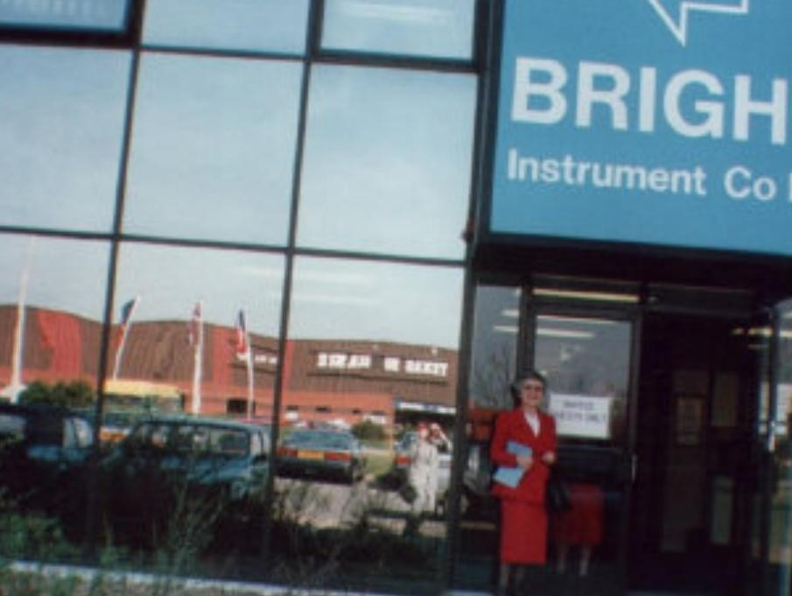

Minnie Silver stands at the entrance of the new factory. Minnie was so very proud of both her brothers.
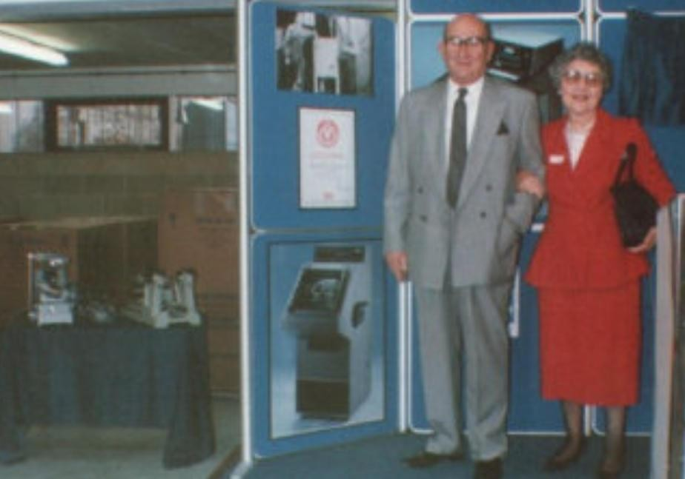

Burly Bright & Minnie Silver

The end of an era.

Sadly, Burly's wife Priscilla Bright (nee Shenfield) passed away in 2006. Burly himself passed away in 2008. In 2014, Alan sold the company to fine people who continue Brights to this day from Luton. In 2015 my Cousin Alan Derek Bright passed away. He had been suffering from a brain tumour! I often think about My Uncle Burly, Aunt Priscilla and my cousin Alan. All gone, but together they created a marvellous company which I remain deeply proud of always. Nothing is forever, but it’s wonderful to have such memories. The photographs of the dedication of the new factory in 1990 are some of my most treasured. Burly invited my parents Minnie and Samuel Silver and Jule & Valerie Bright. Sir John Major KG CH (former UK prime minister) and Mrs Major opened the new factory. Apart from Morris’s being awarded the DSC it must have been one of our family’s outstanding achievements.

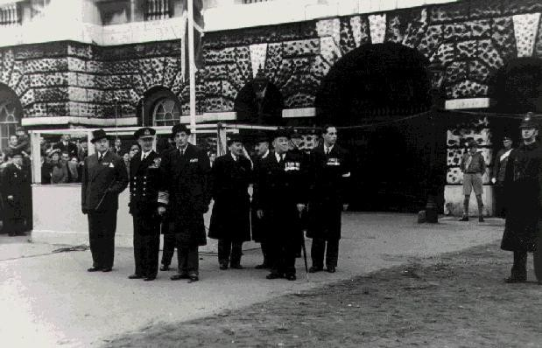

Morris on parade at Jewish
remembrance (second on the right).

After the War Morris continued with the Association of Ex Jewish servicemen (AJAX). He became National vice president and President of the East London branch. In 1948 came a very great honour for Morris. At the Jewish remembrance parade at the Cenotaph London. He was Aide de comp to Admiral Andrew Browne Cunningham, 1st Viscount Cunningham of Hyndhope (1883-1963). Admiral Cunningham had been Mediterranean Commander-in-chief during WW2. First Sea Lord (1943-1946). His reputation was as an outstanding combat officer.
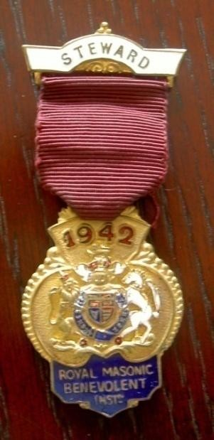

Morris’s Freemason Steward medal
Morris had been a Freemason for many years. My mother Minnie once told me she had seen her father's Masonic apron which is part of the apparel of being a Mason. Two medals are owned by the family. A 1942 Steward medal it reads (Royal Masonic Benevolent inst). The second medal is Masonic and shows the years 1914 to 1918. In 1965 Morris was due to be Admiral Frazer’s flag officer at the Remembrance parade that year. Both men had served in Minerva and I am sure Morris would have considered it a great honour to be selected. Sadly, Morris became too ill to attend and one month later sadly passed away! At the time he was described as “One of the Great architects of Jewish peace”. The truth is it seems, as Jews we long for peace. However, history shows that this probably will never happen.
In his lifetime Morris had seen the change from an almost Victorian run type Royal Navy to a more modern fleet. The defeat of the Kaiser’s Germany and Turkey in World War 1, Anti-Semitism during the inter War years raged to new heights. Leading to the rise of Jewish defence against this evil. He found that there was life outside the Navy building a life with Gertrude and family. He again saw a War where Six Million Jews would be killed by Hitler! The State of Israel established in 1947. Then he saw the early start of Burly’s refrigeration company Brights Instruments.
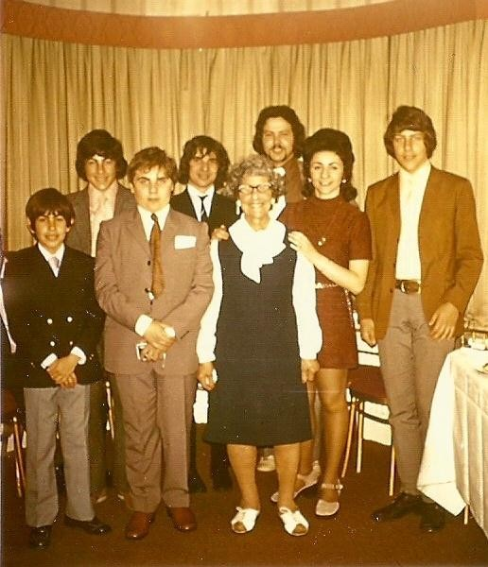

Gertrude Bright with her grandchildren.
Behind left to right. Stephen Bright, Alan Bright, Daniel Zadek, Graham Bright.
In front left to right.
Philip Bright, Simon Silver, Gertrude Bright & Gloria Zadek.

Like all things we are left with memories in the end. My grandmother Gertrude passed away in 1977. I had the very great honour of living with her at 89 Park Avenue North Willesden Green London, in the same house that she had bought with Morris back in the 1930’s, during my teenage years. I know how delighted Gloria both Gertrude & Morris would have been to see the generations of their family develop. This was mainly because Valerie & Jule had almost created the perfect blueprint for the continuation of the Bright’s. So much I have seen over the years is like history repeating itself. My Cousin Stephens’s brilliant technical knowledge of electronics, Graham's Doctorate, Magistrate, acting, singing, entertaining and business presentation skills and Philip also again has a great personality, been outstanding in Jewish community support, acting and business acumen. Each of my cousins have so many of Morris’s and Jule great qualities.

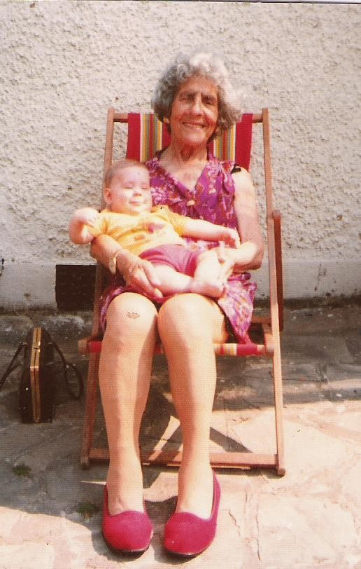

Gertrude Bright holds her great
grandson Mark Zadek born in
Cologne Germany 1975.

My grandmother Gertrude had that pleasure of seeing her granddaughter Gloria Silver marry Daniel Zadek in 1969 and they went to live in Cologne, Germany. She saw her great grandson, Mark. And even went to Cologne to visit the family. After all the awful Wars with Germany, things had moved full circle and we had a German family. Gertrude was never, until the end, held back by her age. She lived with a young heart.

Remembering the past looking to the future

The World changes and moves on! Does it or really has it? We like to think that things have or will improve, but in reality, the same hatreds manifest themselves time after time. The dangers of the World and individuals’ lust for power still exist. Many of the things’ Morris stood against are still around. The attacks and killing of Jews including Synagogues and property outrages are all too common place! Serious attacks on Jews around the World have taken place costing many lives. The State of Israel is in a perpetual state of war against Iran, Hezbollah in Lebanon, Hamas in Gaza & Yemen. Rockets capable of great destruction have been fired by Iran even at Arab states! The UK has had to make tough decisions. Even at a cost of offending our most important Allie the United States. Our economy is fragile and our Royal Navy will take time to modernise. So, it is not like in Morris’s day where the Navy had hundreds of ships and massive man power at its disposal.
You would have thought the need for War by now would be over and a lasting peace found. Far from it! Royal Navy ships main threat is much closer to home than the Middle east. Russia has the ability to undermine and threaten. However, Morris’s would be delighted in the excellent choice of an outstanding First Sea Lord General Sir Gwyn Jenkins KCB OBE Royal Marines. Given the tools and support he will truly make the Royal Navy great again. Personally, I still get a real kick out of hearing a member of the Royal Navy has got an award and the passing out at HMS training bases. I still love to hear about our ships. I am in awe of our two Great aircraft carriers, ships and our latest submarines. I think Morris would have been excited by their technology. I even think he would have liked today's practical dress for Navy personnel. Because we are an island nation our Navy is very vital to us. It always was and I believe will always be so. We must give it all it needs to continue to be the fine service we all know and respect.
Morris, I think, would be proud that Britain has maintained its Monarchy. Even though there have difficult times lately! Health and some scandals. The King has maintained his dignity and has ensured the strength of the throne and future. The UK and continues our international identity on the World stage and is ready to stand up still for democracy and freedom. Even though we are a bit later for the party these days
In the summer of 2023 on a scorching hot day. I visited the graves of Morris & Gertrude in the Jewish Western cemetery in Edmonton London. On that day I visited the graves also of many family members including Morris Wisberg my great grandfather who is in the same cemetery. It was clear that many of the graves need cleaning. I do hope the family read this and we can come up with a plan?
This is a story I hope that is never lost in time. It is about all you can be and never giving up! It is about loving your country however imperfect. It is about loyalty to our King and Royal family. Morris Moss Bright was a patriot and was proud of Britain and being Jewish. I share his values. It is about standing up for our right to exist as Jews in a democratic proper way. It is about loving your family and wanting good things for them. In my working life some of the best people I have ever known are Muslim. I will never believe in giving up the quest for lasting peace. However, you cannot have peace at any price and all sides must work towards it. We must in my view stand with the United States they are our most important Allie and trusted friend.
On the next page is Jule amazing text! When you read it be very proud of Morris Moss Bright’s service to the nation and his devotion to freedom and equality. The wonderful family Morris & Gertrude have left behind. I pray all will continue to be successful always with the Almighty’s help.

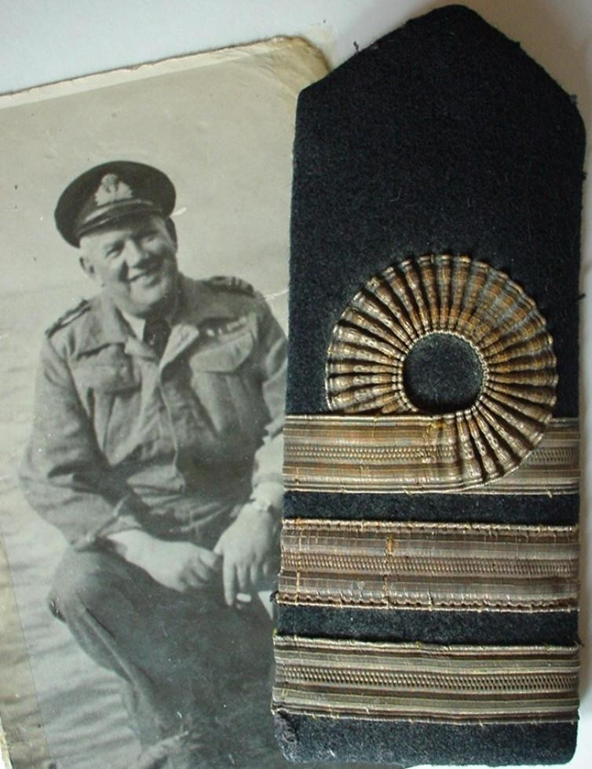

Commander Morris Moss Bright, DSC, RN

The Life and Times of Commander Morris Moss Bright D.S.C R.N by Jule Warwick Bright

